

(INTEGRATIVE PROGRAMMING AND TECHNOLOGIES)

EXERCISE
3

(String and File Handling)

Albert Joseph Candelaria | Dr. Roman DeAngel
January 22, 2020 | January 22, 2020

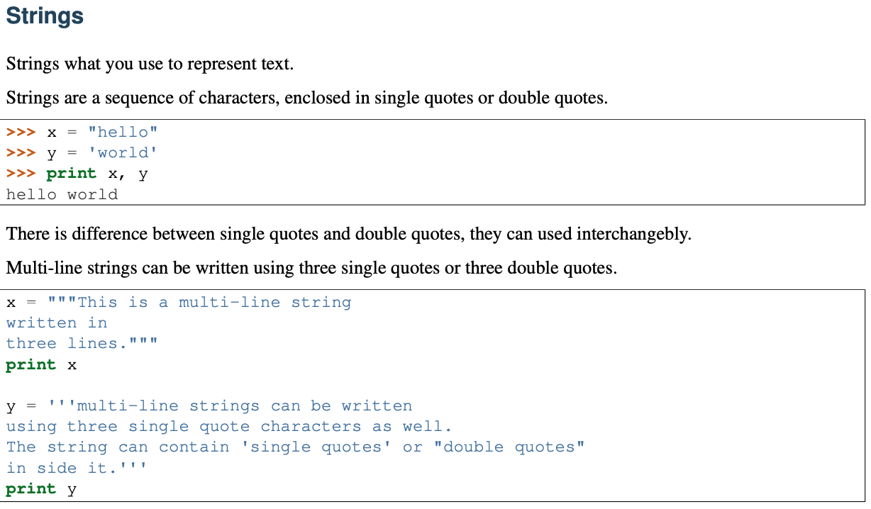
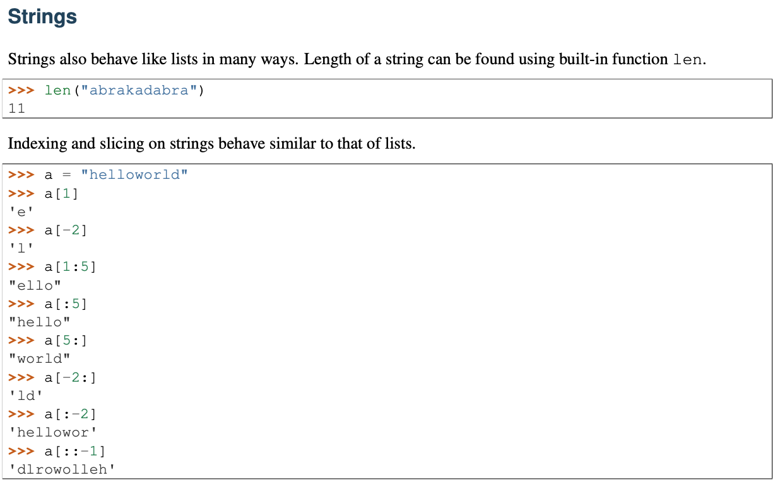
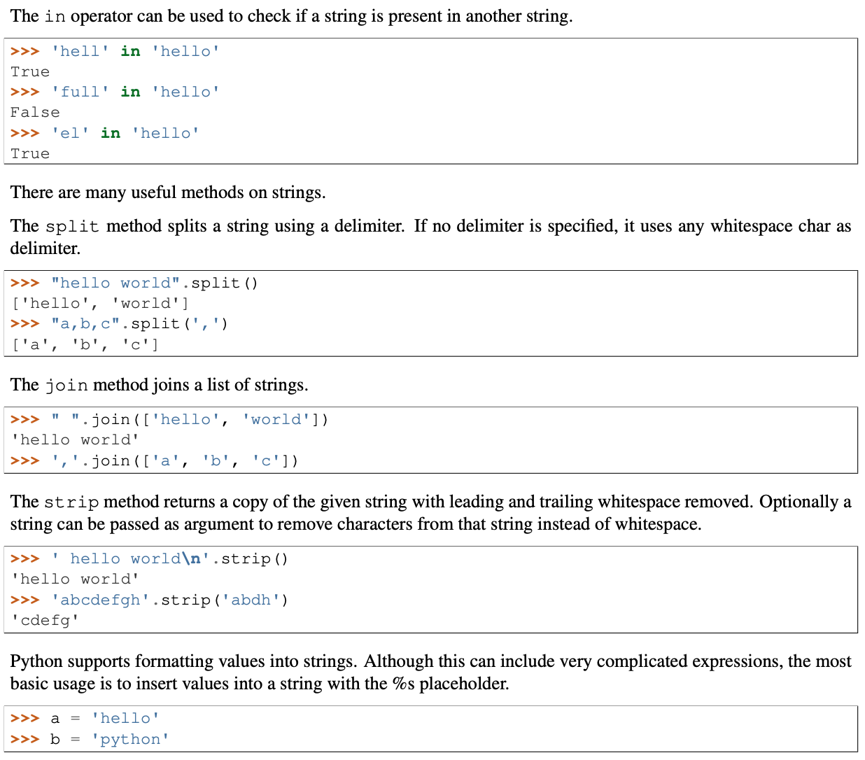

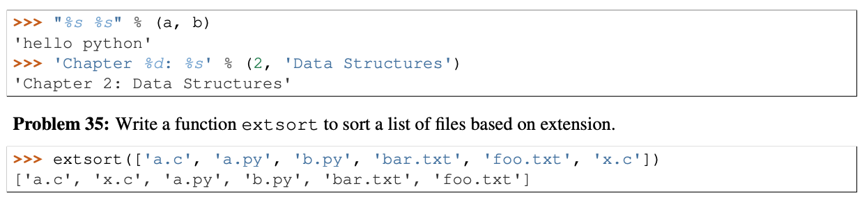
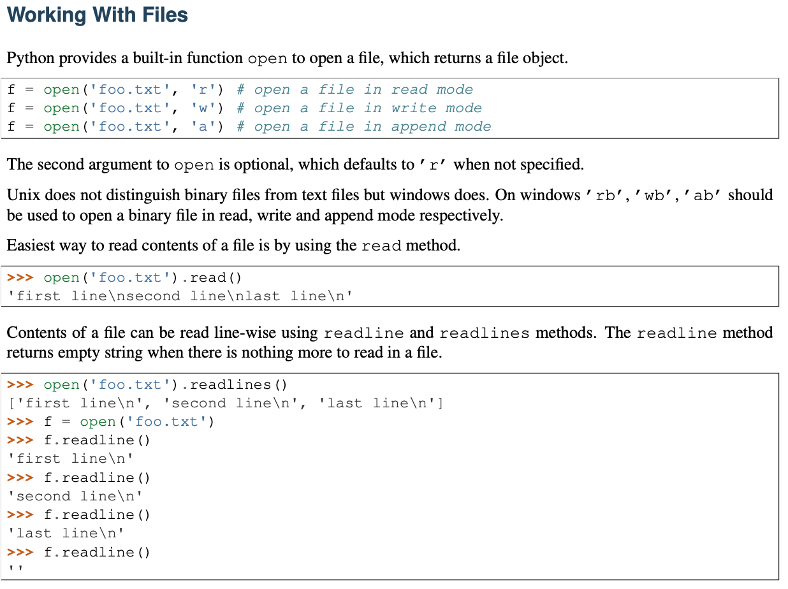
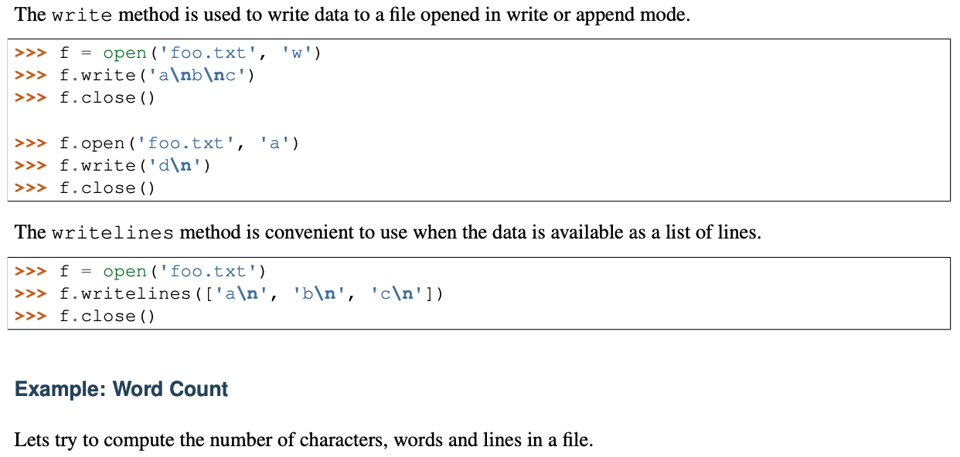
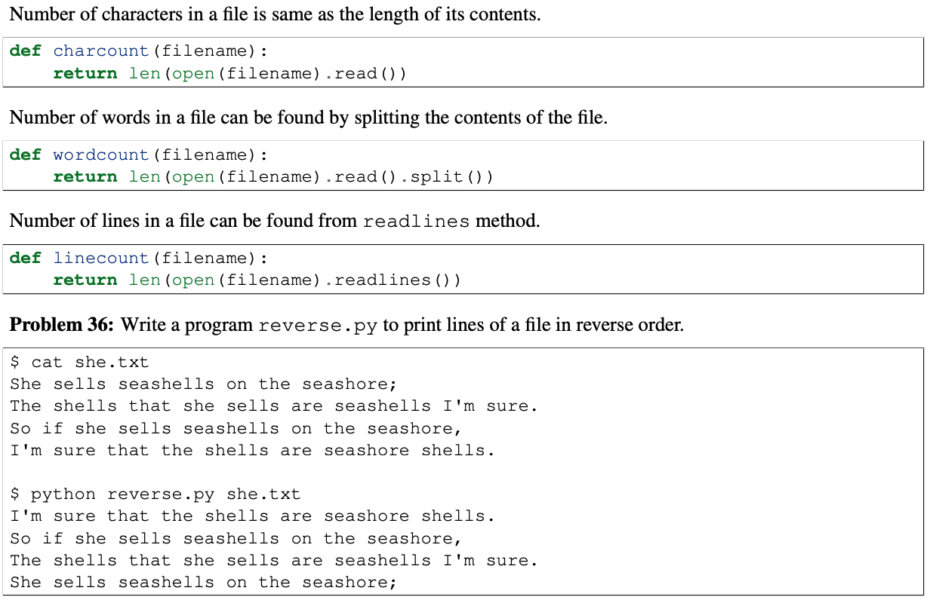
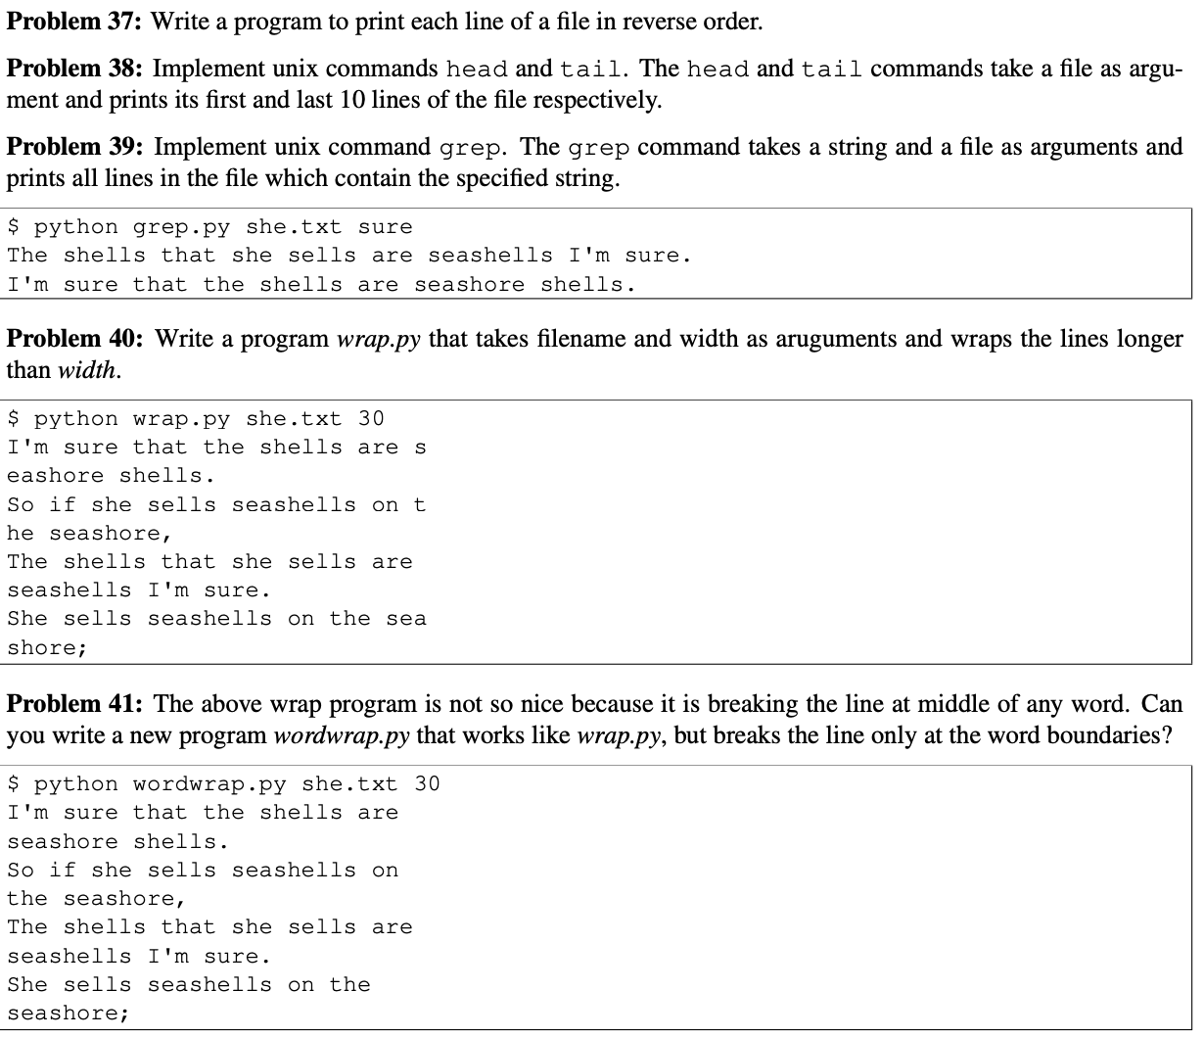
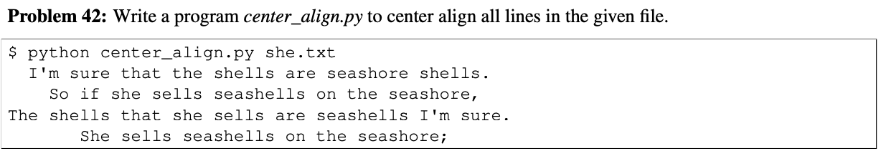

Source Code Problem 35:
import os
files = os.listdir("Problem35Files")
print(f"This is the files in the directory before sorting: {files}")
extensions = []
filenames = []
finalfile = []
for entry in files:
splits = entry.split('.')
extensions.append('.' + splits[-1])
filenames.append(entry)
sorted_filenames = sorted(filenames)
sorted_extension = sorted(extensions)
for final in sorted_extension:
for final2 in sorted_filenames:
if final in final2:
if final2 in finalfile:
print("", end='')
else:
finalfile.append(final2)
else:
print("", end='')
print(f"This is the sorted files: {finalfile}")

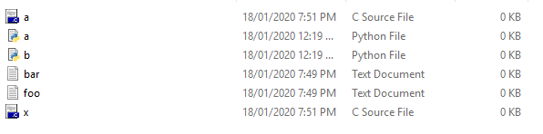

Source Code Problem 36:
content = []
print("\nThis is the content of she.txt before reversing")
f = open("she.txt", "r")
line = f.readline()
while line != '':
print(line.strip())
content.append(line.strip())
line = f.readline()
f.close()
print("\nThis is the reverse lines in she.txt")
ctr = len(content)
ctr -= 1
while ctr >= 0:
print(content[ctr])
ctr -= 1

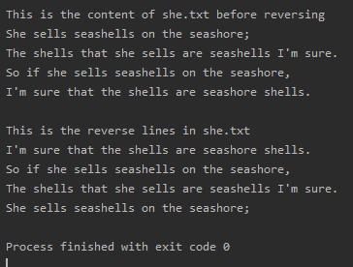

Source Code Problem 37:
content = []
print("\nThis is the content of she.txt before reversing")
f = open("she.txt", "r")
line = f.readline()
while line != '':
print(line.strip())
content.append(line.strip())
line = f.readline()
f.close()
print("\nThis is the reverse order ing each lines in she.txt")
for lines in content:
contwords = lines.split(' ')
len_contwords = len(contwords)
len_contwords -= 1
while len_contwords >= 0:
print(contwords[len_contwords], end=' ')
len_contwords -= 1
print("")

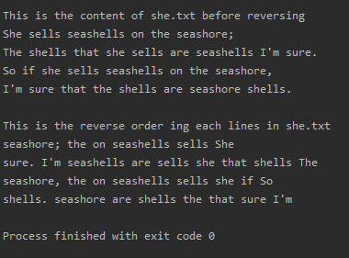

Source Code Problem 38:
content = []
print("\nThis is the content of she.txt")
f = open("she.txt", "r")
line = f.readline()
while line != '':
print(line.strip())
content.append(line.strip())
line = f.readline()
f.close()
print("\nThis is the first 10 lines of she.txt")
for i in range (10):
print(content[i])
print("\nThis is the last 10 lines of she.txt")
lennum = len(content)
lennum -= 1
count = 1
while count <= 10:
print(content[lennum])
lennum -= 1
count+=1
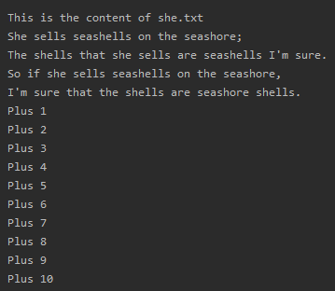

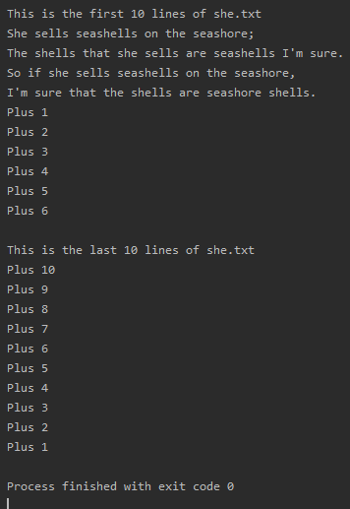
Source Code Problem 39:
content = []
print("\nThis is the content of she.txt")
f = open("she.txt", "r")
line = f.readline()
while line != '':
print(line.strip())
content.append(line.strip())
line = f.readline()
f.close()
inputwords = input("\nEnter a word to find in the lines: ")
lennum = len(content)
for i in range(lennum):
if inputwords in content[i]:
print(content[i])

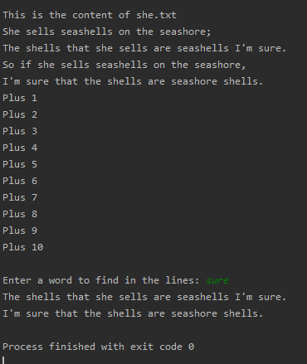

Source Code Problem 40:
content = []
reversecontent = []
f = open("she.txt", "r")
line = f.readline()
while line != '':
content.append(line.strip())
line = f.readline()
f.close()
print("\nThis is the content in she.txt")
ctr = len(content)
ctr -= 1
while ctr >= 0:
reversecontent.append(content[ctr])
print(content[ctr])
ctr -= 1
count = 0
lenwrap = int(input("\n\nEnter the number to wrap: "))
lenwrap -= 1
for lines in reversecontent:
charperlines = lines
numlen = len(charperlines)
for i in range(numlen):
if count <= lenwrap:
print(charperlines[i], end='')
count += 1
else:
print("")
print(charperlines[i], end='')
count = 1
print("")
count = 0

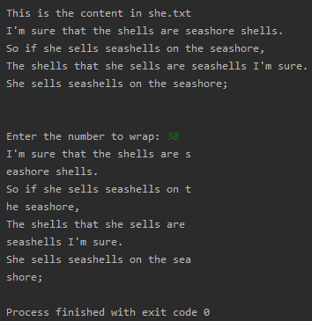

Source Code Problem 41:
content = []
reversecontent = []
f = open("she.txt", "r")
line = f.readline()
while line != '':
content.append(line.strip())
line = f.readline()
f.close()
print("\nThis is the content in she.txt")
ctr = len(content)
ctr -= 1
while ctr >= 0:
reversecontent.append(content[ctr])
print(content[ctr])
ctr -= 1
count = 0
numberofchar = 0
lenwrap = int(input("\n\nEnter the number to wrap: "))
lenwrap -= 1
for lines in reversecontent:
wordsplit = lines.split(' ')
for words in wordsplit:
numberofchar += len(words)
if numberofchar <= 30:
print(words, end=' ')
numberofchar += 1
else:
numberofchar += 1
print("")
print(words, end=' ')
numberofchar = 0
print("")
numberofchar = 0

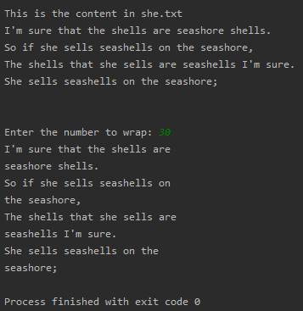

Source Code Problem 42:
content = []
reversecontent = []
f = open("she.txt", "r")
line = f.readline()
while line != '':
content.append(line.strip())
line = f.readline()
f.close()
print("\nThis is the content in she.txt")
ctr = len(content)
ctr -= 1
while ctr >= 0:
reversecontent.append(content[ctr])
ctr -= 1
for line in reversecontent:
text = line.center(50)
print(text)

